CLASS DIAGRAM SPECIFICATION

ONLINE CLOTHING STORE SYSTEM
Online Clothing Store
DGM-03
Class structure, attributes, operations, inheritance, and multiplicity among business objects.
Version 1.0
September 30, 2026
UEF SHOP

Class Diagram Specification
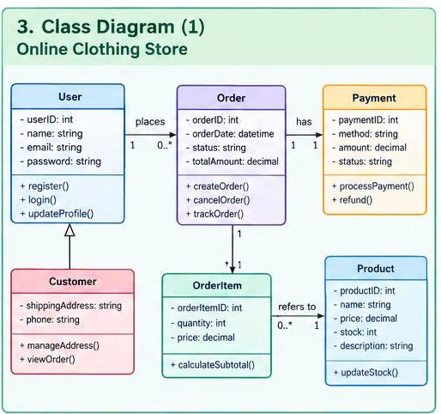
Figure 1. Class Diagram for the Online Clothing Store system

Class Model Scope
The Class Diagram represents six core domain classes: User, Customer, Order, OrderItem, Product, and Payment. The model focuses on business data and behavior; it does not yet include UI, repository, or integration service classes.

Class Dictionary
Class | Responsibility | Attributes | Operations
User | Common identity and authentication behavior. | userID: int  name: string  email: string  password: string | register()  login()  updateProfile()
Customer | Shopping information that extends User. | shippingAddress: string  phone: string | manageAddress()  viewOrder()
Order | Represents a purchase transaction. | orderID: int  orderDate: datetime  status: string  totalAmount: decimal | createOrder()  cancelOrder()  trackOrder()
OrderItem | Represents one product line in an order. | orderItemID: int  quantity: int  price: decimal | calculateSubtotal()
Product | Represents a product offered for sale and its inventory. | productID: int  name: string  price: decimal  stock: int  description: string | updateStock()
Payment | Payment information associated with an order. | paymentID: int  method: string  amount: decimal  status: string | processPayment()  refund()

Relationships and Multiplicity
Relationship | Multiplicity | Meaning
Customer inherits from User | Generalization | Customer uses the identity, email, and authentication behavior of User while adding address and phone information.
User places Order | 1 ↔ 0..* | A User may have no Orders or many Orders; each Order belongs to one User.
Order contains OrderItem | 1 ↔ 1..* | Each Order has at least one OrderItem; an OrderItem cannot exist independently.
OrderItem refers to Product | 0..* ↔ 1 | Each OrderItem references exactly one Product; a Product may appear in many OrderItem records.
Order has Payment | 1 ↔ 1 | Each Order has one Payment in the scope of the current version.

Class Invariants
Code | Invariant
INV-01 | User.email is not empty and is unique.
INV-02 | Order.totalAmount = the sum of OrderItem.quantity x OrderItem.price.
INV-03 | OrderItem.quantity > 0 and OrderItem.price >= 0.
INV-04 | Product.stock >= 0; updateStock() must not produce negative inventory.
INV-05 | Payment.amount equals Order.totalAmount for full payment.
INV-06 | Order.status accepts only values defined in the State Diagram.

Implementation Notes
The password attribute shown in the diagram must be implemented as passwordHash; plaintext passwords must never be stored. The implementation should use enum types for Order.status, Payment.status, and Payment.method. calculateSubtotal() returns quantity x price; totalAmount should be calculated by a service layer or by Order from its OrderItem collection to prevent inconsistencies.

